**Lesson 12: Assessment**

**For each of the following questions, please solve or circle your answer from the given choices. Below the question, please show all the steps you used to find the answer. Then, explain why your answer is correct or why the other answers are wrong.**

**Problem One:**

I flip a fair coin three times. What is the probability that I get three heads? HINT: Draw your sample space.

**Steps to get your answer:**

**Justify/explain why your answer is correct or makes sense:**

**Problem Two:**

The following is a graph of students who applied to UC Berkeley from my old high school. It also includes information on the number of those students who were accepted and those who enrolled in UCB. Use the graph to answer the following questions:

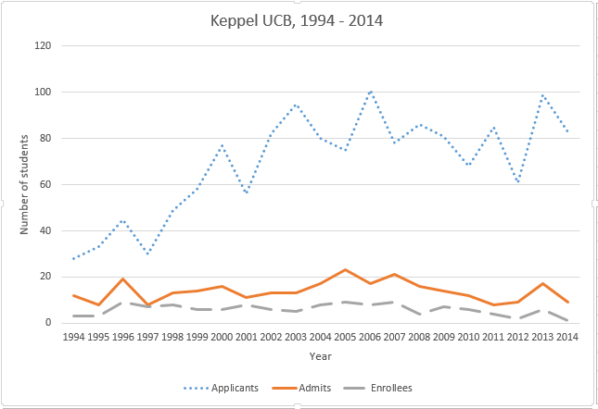

1. Describe the overall trends of the three lines.
2. During which year was there the highest number of applicants to UC Berkeley? How many students applied?

Now look at the following graph, which details trends in admissions for UC Riverside

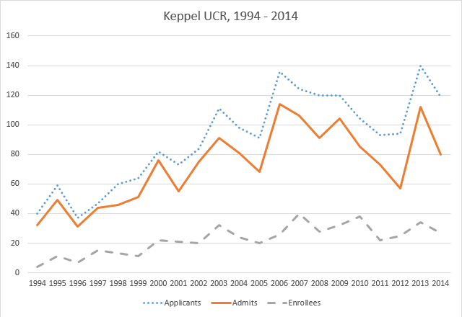

1. What is one similarity between the trends in the UC Berkeley and the UC Riverside graphs? What is one difference?
2. Based on data from the graphs, which school would offer you a better chance of getting in? Explain.

**Problem Three:**

1. I have 2 gray shirts and 3 blue shirts. I decided to choose one shirt to wear at random. What is the probability that I pick a blue shirt?
2. EXTRA CREDIT: Now let’s assume that I did decide to wear a blue shirt and after a hard day at work, it’s in the washing machine. From the remaining clothes, I pick another shirt to wear. What is the probability that I pick a gray shirt? HINT: How does the sample space change?

**Problem Four:**

$$\frac{w}{4}-\left(-6\right)=10. Find w.$$

**Steps to get your answer:**

**Justify/explain why your answer is correct or makes sense:**

**Problem Five:**

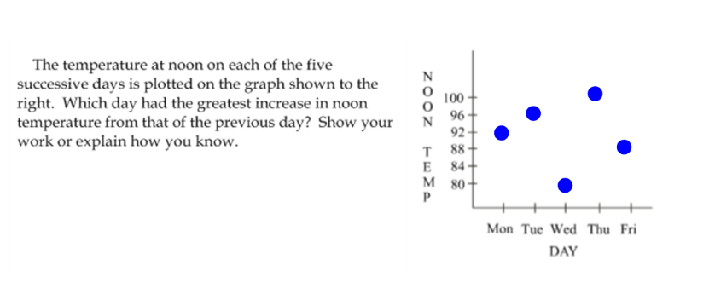

**Steps to get your answer:**

**Justify/explain why your answer is correct or makes sense:**

**Problem Six:**

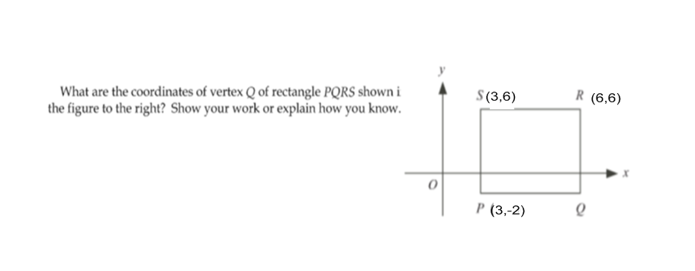

**Steps to get your answer:**

**Justify/explain why your answer is correct or makes sense:**